Your Migration Go Live - Post Migration Checks and

Creating Your School’s Opening Position.

**This document is for the attention of the designated Arbor Finance School Lead. This person would have been named as the lead contact, receiving all initial communications from Arbor Finance and RM Unify.**

**This is your step by step process to support the validation of the accounts that have been migrated to Arbor Finance.**

**Before moving ahead,** it is important to have completed ALL the self study and Live training sessions.

*Missed a session?* Simply work through the relevant training notes, alongside the Arbor Finance Training Suite to practise procedures. The training suite will continue to be available for a short while, so anyone can practise ahead of any live processing.

Please remember, **transactional data has not been migrated**. We ask that balances are checked against reports from the incumbent system or the school’s migration workbook - simply follow the instructions in this document.

**If there are outstanding commitments**, these will have to be re-entered before completing the final migration step - running period end.

**All of these steps must be completed before posting any new transactions in Arbor Finance.**

**Access Arbor Finance for Your School**RM Unify administrators should login to Unify using the rmunifyadmin@xxxxxx username and password that was used on initial setup of the school’s live launchpad. Via the launchpad, access Arbor Finance by clicking on the Arbor Finance tile.

**Validating The Financials**

To validate the figures match what you uploaded from the original system, you should work through the instructions below. You need to complete [the Arbor Finance Data Validation Report](https://docs.google.com/forms/d/1k7V0Dw5wxdqlcsiDEauDrdFz-QFUNXm-aboqr426V9U/edit) to verify your acceptance of the migration and your Go Live position.  
  
**1. Check bank balances and VAT Debtor:**Run the following report: Reporting > Transactions > General > Balance and Reserves Report  
Confirm the figures match the Balance & Reserves exported from your old system..

**2. Check Nett YTD**Run the following report: Reporting>Records>Budgets>Budget vs Actual vs Committed.

Confirm the Balance for All Accounts figure at the bottom of the report for **Actual Spend/Received** matches the Current Balances Total from the Balance and Reserves report ran from your old system prior to migration.

**IF THE FIGURES DO NOT MATCH, DO NOT PROCEED IN ARBOR FINANCE. PLEASE CONTACT YOUR SUPPORT TEAM.**

**3. Mark ALL Imported Transactions as claimed on VAT reports:**

Reporting > Transactions > VAT > VAT Submittal  
Print report for your records

Go to Reporting > Transactions > VAT> VAT Report  
Select Periods 1 - 12  
Include ALL bank accounts.  
Generate the report. Save a PDF copy for reference.

Close the report window, and when prompted select ‘Have you saved this’ click YES.  
‘Do you want to make these transactions as claimed’ click YES

**4. Set Up BACS (if applicable)**

System > System Setup > Options > Transactions > Payments Printing > Ensure this is set to ON and Cheques/BACS is selected and Save.  
System > System Setup > Bank Details.  
Click Edit to add relevant BACS details to the BACS bank account.

Enter Account No. and Sort Code.  
Toggle YES to Allow BACS Payments.  
Select relevant banking file format from BACS Transfer Format drop down list.  
Select Active from Status drop down list.

**5. Import Contacts**

We suggest you start with a list of contacts from your incumbent system. You may have already prepared this, editing out unused contacts. The ideal data set, to facilitate BACS and cheque payments is as follows: Building from data extracted, you will want to build an extended customer/supplier database.

| **EXTRACT?**  Supplier and or Customer Contact  Address (lines 1-5)  Postcode  Phone1 (and 2)  VatNumber  Email | **DATA ENTRY**  Cheque Y/N  Bacs Y/N  DirectDebit Y/N  Remittance email Remittance method Alternative Payee Company Type | **BACS DETAILS**  Bank name SortCode  AccountNo  BACS reference  Contact position Company registration  Supplier terms |
| --- | --- | --- |

Bank details may not be readily exported from your system, so it is probably a manual task to add bank sort code (6 digits), bank account number (8 digits). Importing this as CSV will allow you to pay by BACS.

NB: If you have bank details that begin with 0 - you will need to build your data in CSV or create a field in EXCEL as a TEXT field. Final file is best saved as CSV, checking those pesky “leading zeros” stay in place!

Records > Contacts >Import   
Import contacts via the Import function ensuring that the relevant details have been populated as per the template.

**6. Import Budget/Analysis Links and allocations.**  
To do this, you will need the budget allocation file that you created in step 7 of the migration instructions.

We will use this both to define the linking of budget and analysis codes, to prevent mis-postings *and can also use this information to post budget allocations.*

This file can be imported to Arbor Finance from System > Import Budgets.

A help article for this process can be found [here](https://arborfinance.zendesk.com/hc/en-gb/articles/20923719476509-Importing-Budgets-Budget-and-Analysis-codes#h_01J5D9WBHBW8RH0R4VGRN00J6M)

**7. Run Period End**Click Period End, follow through the prompts to complete the wizard.

For more help with the process, within the Period End area, click on the Help Centre icon and review [Period end (arbor-education.finance)](https://help.arbor-education.finance/period_end)

You will find a summary recording of the process [Help Centre Period Month End Demonstration](https://help.arbor-education.finance/topic/awsfiles/download_files?ref=https://dzf8vqv24eqhg.cloudfront.net/userfiles/38142/48696/ckfinder/files/Videos/Month%20End%20v2.mp4)

​  
As part of the process, a summary is displayed for checking reconciliation/batched transactions (this does not apply at point of migration).​

At this point, as Finance Lead you should be the only active user. If not, please make sure all users are logged out before hitting the “run period end” button. To force a logout of a user see the Help Centre instructions [How to remove user lock (arbor-education.finance)](https://help.arbor-education.finance/how-to-remove-user-lock)

**On completion you should now be in the new month/ period**

***Remember to complete and Submit the***

***Your School Migration Confirmation Acceptance in your Week 7 ema*il**

***Move to Step 8 - adding other users***

***Then Step 9 posting commitments***

**8. Add any other finance users/make user active**

8.1. Logon to RM Unify as an Administrator this is with the rmunifyadmin@xxx username and password.

8.2. Click on the **Management Console** option at the top of the screen.

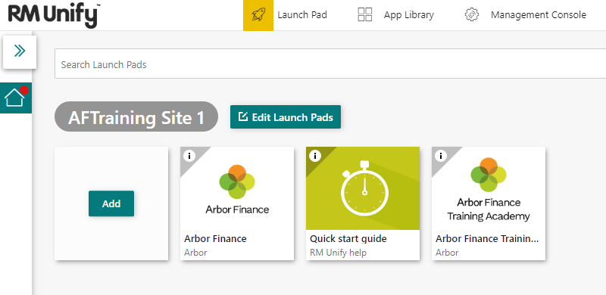

8.3. Click **Users** on the left hand side of the screen.

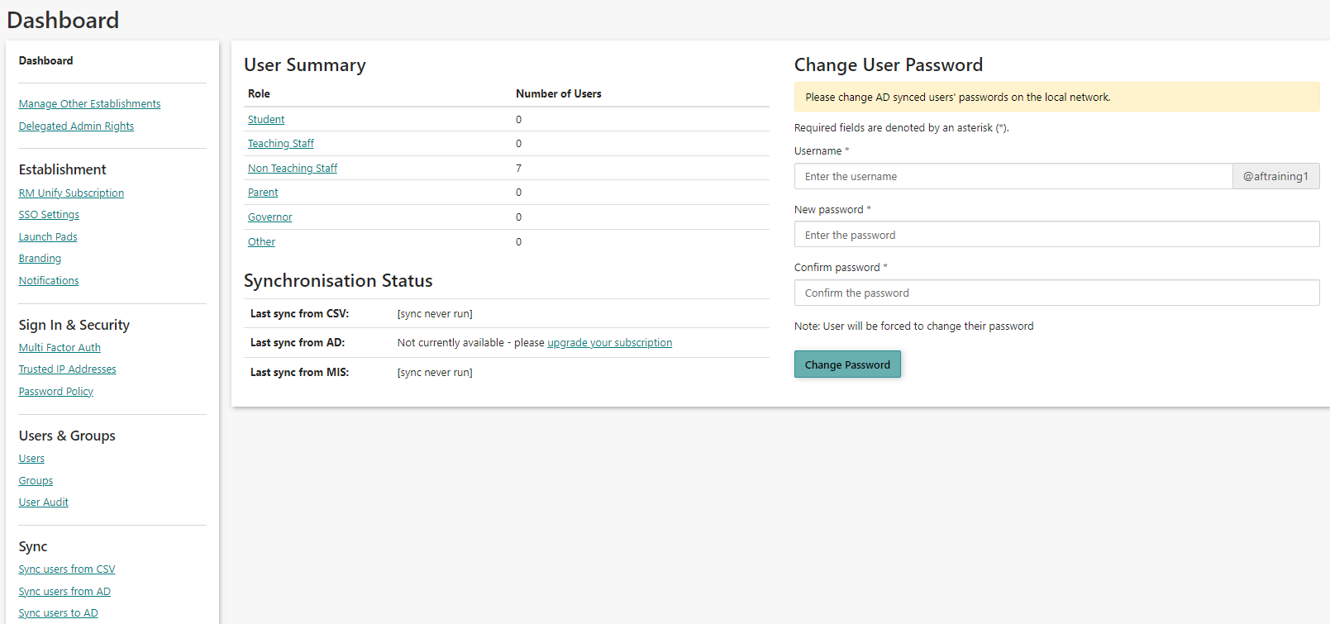

8.4. Click on the **Actions** button and then **Create User**.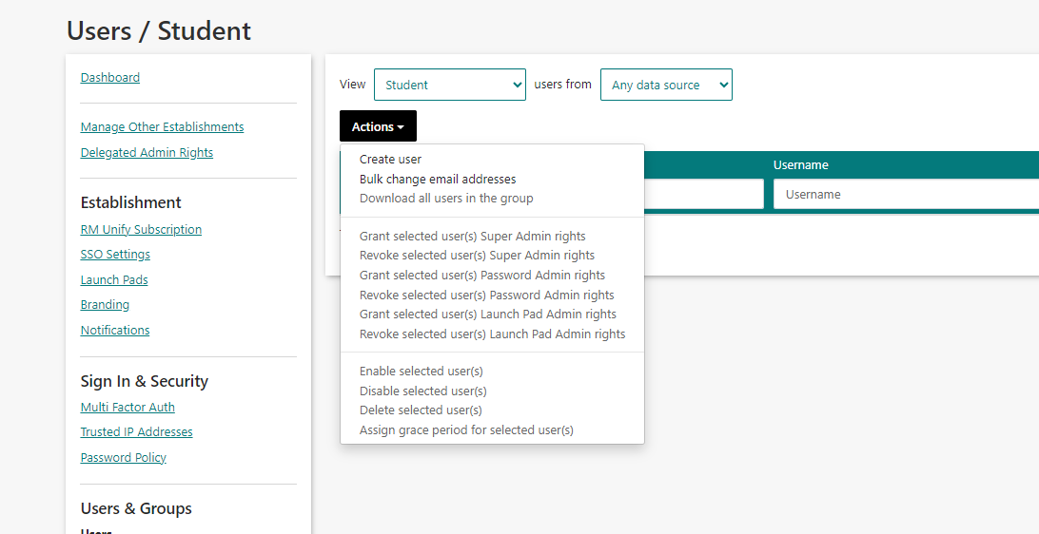

8.5. Enter the details of the new user into the relevant boxes. Choose **the user type.**

If you want to grant the new user admin rights, place a tick in the 'Give user admin rights' box.

If setting up a user account for someone else, you should tick 'Make the user change their password on first login'.

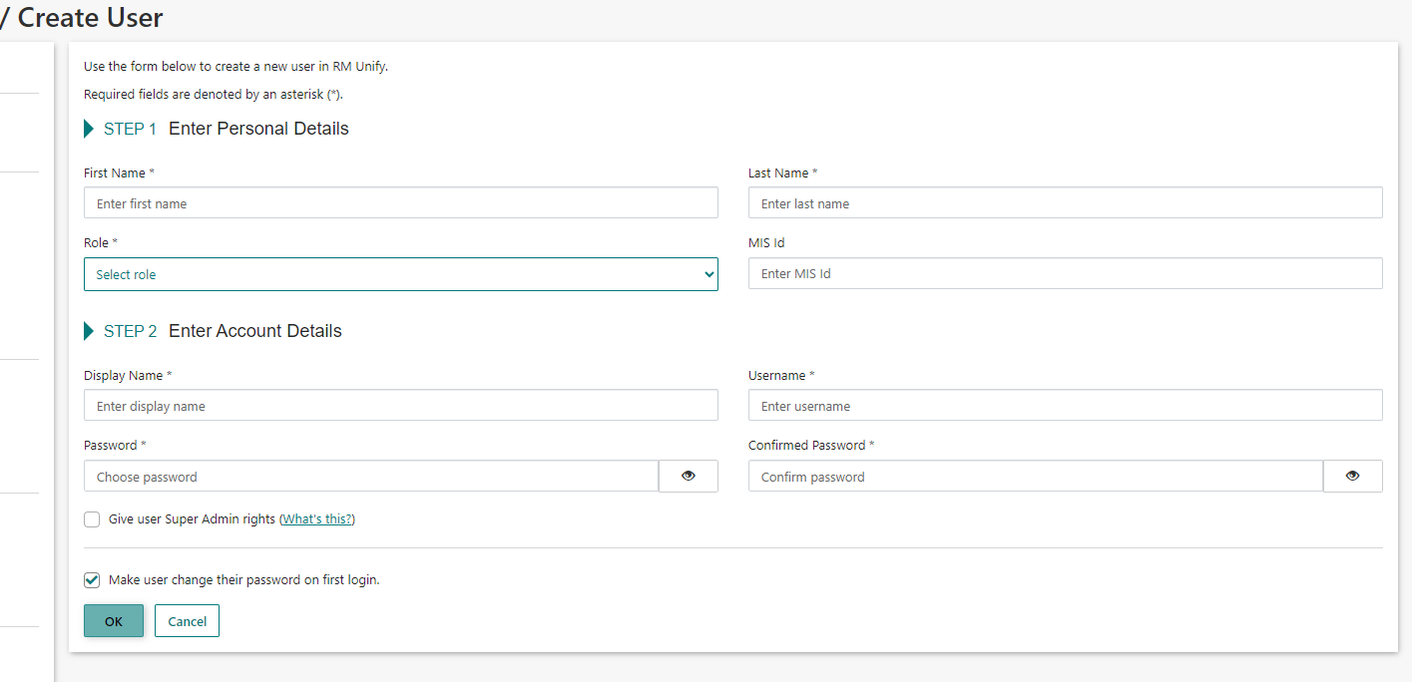

Users will not be able to access Arbor Finance if they are not set as Non Teaching Staff.

8.6. When the user attempts to log in, they will be greeted by this page:

**They should log out and at this point and advise the Admin user they are ready to be made active in Arbor Finance.**

8.7. The Admin user who has full access to Arbor Finance should then login to Arbor Finance and go to **System > System Setup > User Details.**

Select the user that is inactive, click on **Edit** on the right-hand side and change the status from **Inactive** to **Active and add the users initials**.

**Set the appropriate user permissions - go to** [**System setup user details**](https://help.arbor-education.finance/system_setup_user_details)**.**

NB:

* FULL would suit the SBM/Finance Manager
* CUSTOM - you would want to select limited permissions for your team who perhaps only process Purchase Orders? Or perhaps are authorising staff only.

Then click on Save.

8.8. The new user will now be able to log in and access the Arbor finance tile.

**9. Commitments**

Commitments were not migrated and should therefore now be re-entered into Arbor Finance as purchase orders.

**NB**: *it will not be necessary to email the Purchase Order from Arbor Finance to your supplier as you'll have done this already in your old system.*

After posting your commitments, confirm the total **Committed** value on the Budget Vs Actual vs Committed matches the total of the committed column from your Balance & Reserves report printed prior to migration

**10. Final Step**

**Please email your support team (local or direct with Arbor)** to confirm that you have successfully migrated to Arbor Finance, clearly stating that all the financials agree with the source data, exported from FMS.

**CONGRATULATIONS - YOU HAVE NOW COMPLETED DATA VALIDATION AND CAN NOW BEGIN TO POST IN ARBOR FINANCE**